

Mark Scheme (Final)

Summer 2007

Edexcel Limited. Registered in England and Wales No. 4496750
Registered Office: One90 High Holborn, London WC1V 7BH


GCE



GCE Mathematics (6664/01)

General Principal for Pure Mathematics Marking

(But note that specific mark schemes may sometimes override these general principles).

Method mark for solving 3 term quadratic:

1. Factorisation

, leading to x = …

, leading to x = …

2. Formula

Attempt to use correct formula (with values for a, b and c).

3. Completing the square

Solving 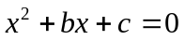: 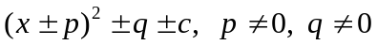, leading to x = …

Method marks for differentiation and integration:

1. Differentiation

Power of at least one term decreased by 1. (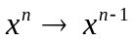)

2. Integration

Power of at least one term increased by 1. (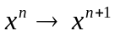)

Use of a formula

Where a method involves using a formula that has been learnt, the advice given in recent examiners’ reports is that the formula should be quoted first.

Normal marking procedure is as follows:

Method mark for quoting a correct formula and attempting to use it, even if there are mistakes in the substitution of values.

Where the formula is not quoted, the method mark can be gained by implication from correct working with values, but may be lost if there is any mistake in the working.

Exact answers

Examiners’ reports have emphasised that where, for example, an exact answer is asked for, or working with surds is clearly required, marks will normally be lost if the candidate resorts to using rounded decimals.

Answers without working

The rubric says that these may not gain full credit. Individual mark schemes will give details of what happens in particular cases. General policy is that if it could be done “in your head”, detailed working would not be required. Most candidates do show working, but there are occasional awkward cases and if the mark scheme does not cover this, please contact your team leader for advice.

June 2007

6664 Core Mathematics C2

Mark Scheme

Question Scheme Marks
number

1. 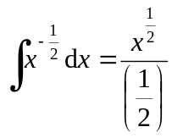 (Or equivalent, such as 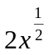, or 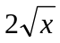) M1 A1
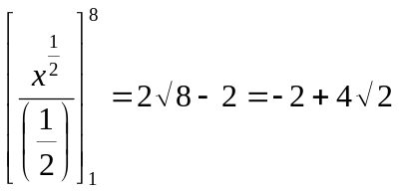 [or 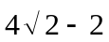, or 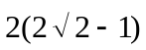, or 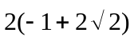] M1 A1
(4)
4

1st M: 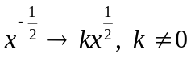.

2nd M: Substituting limits 8 and 1 into a ‘changed’ function (i.e. not 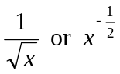),

and subtracting, either way round.

2nd A: This final mark is still scored if 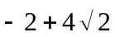 is reached via a decimal.

N.B. Integration constant +C may appear, e.g.

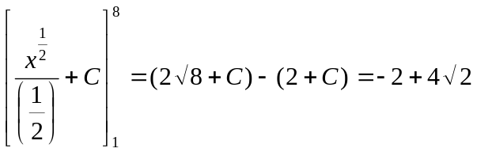 (Still full marks)

But… a final answer such as 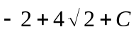 is A0.

N.B. It will sometimes be necessary to ‘ignore subsequent working’ (isw) after a

correct form is seen, e.g. (M1 A1), followed by incorrect

simplification 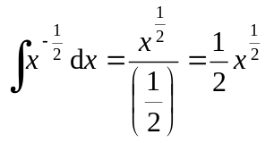 (still M1 A1)…. The second M mark

is still available for substituting 8 and 1 into 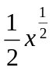 and subtracting.

Question Scheme Marks
number

2. (a) f(2) = 24 – 20 – 32 + 12 = –16 (M: Attempt f(2) or f(–2)) M1 A1 (2)

(If continues to say ‘remainder = 16’, isw)

Answer must be seen in part (a), not part (b).

(b) 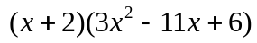 M1 A1

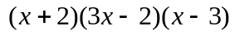 M1 A1 (4)

(If continues to ‘solve an equation’, isw)

6

(a) Answer only (if correct) scores both marks. (16 as ‘answer only’ is M0 A0).

Alternative (long division):

Divide by (x − 2) to get 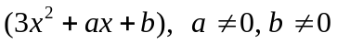. [M1]

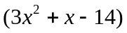, and – 16 seen. [A1]

(If continues to say ‘remainder = 16’, isw)

(b) First M requires division by (x + 2) to get .

Second M for attempt to factorise their quadratic, even if wrongly obtained,

perhaps with a remainder from their division.

Usual rule: .

Just solving their quadratic by the formula is M0.

“Combining” all 3 factors is not required.

Alternative (first 2 marks):

, then compare

coefficients to find values of a and b. [M1]

a = –11, b = 6 [A1]

Alternative:

Factor theorem: Finding that 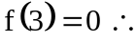factor is, 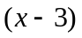 [M1, A1]

Finding that 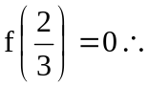 factor is, 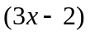 [M1, A1]

If just one of these is found, score the first 2 marks M1 A1 M0 A0.

Losing a factor of 3: 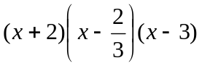 scores M1 A1 M1 A0.

Answer only, one sign wrong: e.g.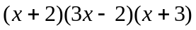 scores M1 A1 M1 A0.

Question Scheme Marks
number

3. (a) 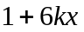 [Allow unsimplified versions, e.g. 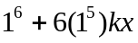, 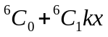] B1
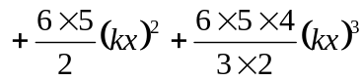 [See below for acceptable versions] M1 A1 (3)
N.B. THIS NEED NOT BE SIMPLIFIED FOR THE A1 (isw is applied)
(b) 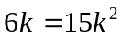 k = 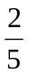 (or equiv. fraction, or 0.4) (Ignore k = 0, if seen) M1 A1cso (2)
(c) 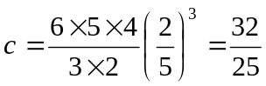 (or equiv. fraction, or 1.28) A1cso (1)
(Ignore 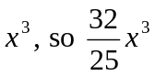 is fine)

6
- The terms can be ‘listed’ rather than added.

M1: Requires correct structure: ‘binomial coefficients’ (perhaps from Pascal’s

triangle), increasing powers of x. Allow a ‘slip’ or ‘slips’ such as:

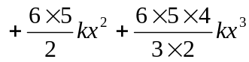, 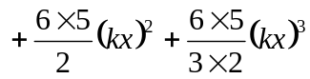

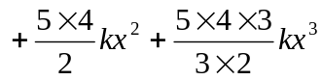, 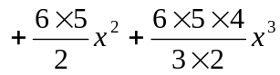

But: 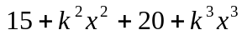 or similar is M0.

Both 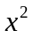 and 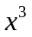 terms must be seen.

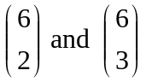 or equivalent such as 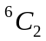 and 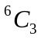are acceptable, and

even 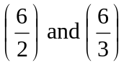 are acceptable for the method mark.

A1: Any correct (possibly unsimplified) version of these 2 terms.

or equivalent such as and are acceptable.

Descending powers of x:

Can score the M mark if the required first 4 terms are not seen.

Multiplying out :

M1: A full attempt to multiply out (power 6)

B1 and A1 as on the main scheme.

(b) M: Equating the coefficients of x and 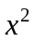 (even if trivial, e.g. 6k = 15k).

Allow this mark also for the ‘misread’: equating the coefficients of and 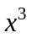.

An equation in k alone is required for this M mark, although…

…condone 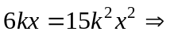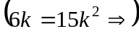 k = .

Question Scheme Marks
number

4. (a) 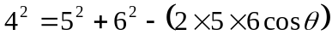 M1

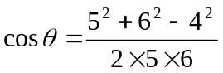 A1 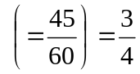 (*) A1cso (3)

(b) 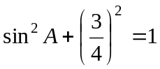 (or equiv. Pythag. method) M1

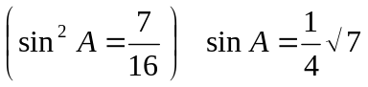 or equivalent exact form, e.g. 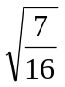, 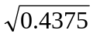 A1 (2)

5

(a) M: Is also scored for 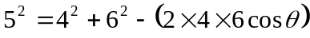

or 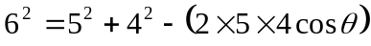

or 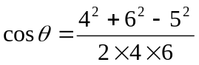 or 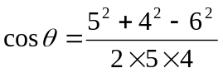 .

1st A: Rearranged correctly and numerically correct (possibly unsimplified),

in the form 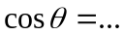 or 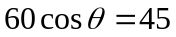 (or equiv. in the form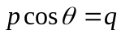).

Alternative (verification):

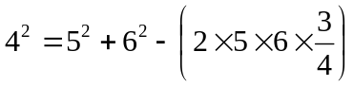 [M1]

Evaluate correctly, at least to 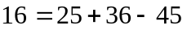 [A1]

Conclusion (perhaps as simple as a tick). [A1cso]

(Just achieving 16 = 16 is insufficient without at least a tick).

- M: Using a correct method to find an equation in 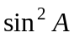 or 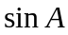 which

would give an exact value.

Correct answer without working (or with unclear working or decimals):

Still scores both marks.

Question Scheme Marks
number

5. (a) 1.414 (allow also exact answer √2), 3.137 Allow awrt B1, B1 (2)

(b) 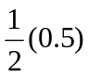…. B1

…. 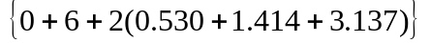 M1 A1ft

= 4.04 (Must be 3 s.f.) A1 (4)

(c) Area of triangle = 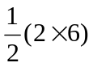 B1

(Could also be found by integration, or even by the trapezium rule on y = 3x)

Area required = Area of triangle − Answer to (b) (Subtract either way round) M1

6 – 4.04 = 1.96 Allow awrt A1ft (3)

(ft from (b), dependent on the B1, and on answer to (b) less than 6)

9
- If answers are given to only 2 d.p. (1.41 and 3.14), this is B0 B0, but full marks

can be given in part (b) if 4.04 is achieved.

(b) Bracketing mistake: i.e. 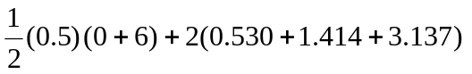

scores B1 M1 A0 A0 unless the final answer implies that the calculation has

been done correctly (then full marks can be given).

Alternative (finding and adding separate areas):

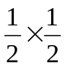 (Triangle/trapezium formulae, and height of triangle/trapezium) [B1]

Fully correct method for total area, with values from table. [M1, A1ft]
  - [A1]

- B1: Can be given for 6 with no working, but should not be given for 6

obtained from wrong working.

A1ft: This is a dependent follow-through: the B1 for 6 must have been scored,

and the answer to (b) must be less than 6.

Question Scheme Marks
number

6. (a) 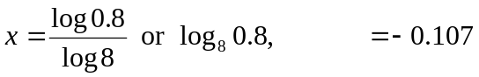 Allow awrt M1, A1 (2)

(b) 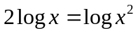 B1

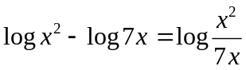 M1

“Remove logs” to form equation in x, using the base correctly: 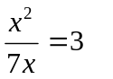 M1

x = 21 (Ignore x = 0, if seen) A1cso (4)

6

(a) Allow also the ‘implicit’ answer 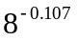 (M1 A1).

Answer only: −0.107 or awrt: Full marks.

Answer only: −0.11 or awrt (insufficient accuracy): M1 A0

Trial and improvement: Award marks as for “answer only”.

(b) Alternative:

B1

M1

“Remove logs” to form equation in x: 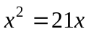 M1

x = 21 (Ignore x = 0, if seen) A1

Alternative:

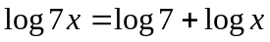 B1

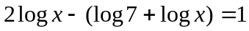

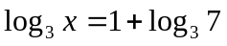 M1

M1

x = 21 A1

Attempts using change of base will usually require the same steps as in the

main scheme or alternatives, so can be marked equivalently.

A common mistake:

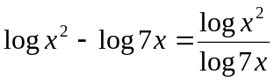 B1 M0

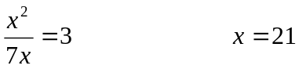 M1(‘Recovery’), but A0

Question Scheme Marks
number

7. (a) Gradient of AM: 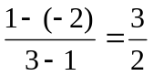 or 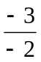 B1

Gradient of l: 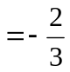 M: use of 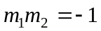, or equiv. M1

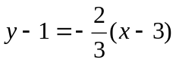 or 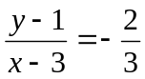 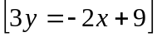 (Any equiv. form) M1 A1 (4)

(b) x = 6: 3y = –12 + 9 = –3 y = –1 (or show that for y = –1, x = 6) (*) B1 (1)

(A conclusion is not required).

(c) 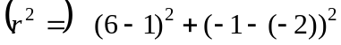 M: Attempt 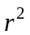 or r M1 A1

N.B. Simplification is not required to score M1 A1

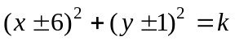, 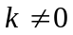 (Value for k not needed, could be 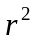 or r) M1

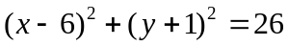 (or equiv.) A1 (4)

Allow 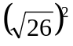 or other exact equivalents for 26.

(But… 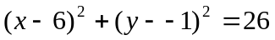 scores M1 A0)

(Correct answer with no working scores full marks)

9
- 2nd M1: eqn. of a straight line through (3, 1) with any gradient except 0 or ∞.

Alternative: Using (3, 1) in 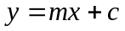 to find a value of c scores M1, but

an equation (general or specific) must be seen.

Having coords the wrong way round, e.g. 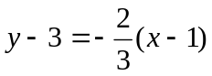, loses the

2nd M mark unless a correct general formula is seen, e.g. 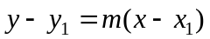.

If the point P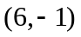is used to find the gradient of MP, maximum marks

are (a) B0 M0 M1 A1 (b) B0.

(c) 1st M1: Condone one slip, numerical or sign, inside a bracket.

Must be attempting to use points P(6, −1) and A(1, −2), or perhaps P and B.

(Correct coordinates for B are (5, 4)).

1st M alternative is to use a complete Pythag. method on triangle MAP,

n.b. 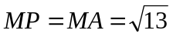.

Special case:

If candidate persists in using their value for the y-coordinate of P instead of the

given −1, allow the M marks in part (c) if earned.

Question Scheme Marks
number

8. (a) 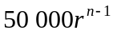 (or equiv.) (Allow 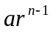 if is seen in (b)) B1 (1)

(b) 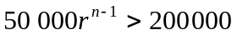 M1

(Using answer to (a), which must include r and n, and 200 000)

(Allow equals sign or the wrong inequality sign)

(Condone ‘slips’ such as omitting a zero)

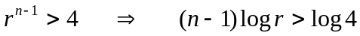 M1

(Introducing logs and dealing correctly with the power)

(Allow equals sign or the wrong inequality sign)

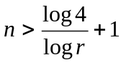 (*) A1cso (3)

(c) r = 1.09: 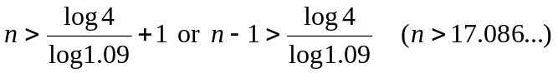 (Allow equality) M1

Year 18 or 2023 (If one of these is correct, ignore the other) A1 (2)

(d) 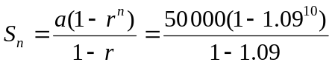 M1 A1

£760 000 (Must be this answer… nearest £10000) A1 (3)

9
- Incorrect inequality sign at any stage loses the A mark.

Condone missing brackets if otherwise correct, e.g 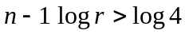.

A common mistake: M1

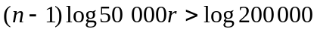 M0

(‘Recovery’ from here is not possible).
- Correct answer with no working scores full marks.

Year 17 (or 2022) with no working scores M1 A0.

Treat other methods (e.g. “year by year” calculation) as if there is no working.
- M1: Use of the correct formula with a = 50000, 5000 or 500000, and

n = 9, 10, 11 or 15.

M1 can also be scored by a “year by year” method, with terms added.

(Allow the M mark if there is evidence of adding 9, 10, 11 or 15 terms).

1st A1 is scored if 10 correct terms have been added (allow “nearest £100”).

(50000, 54500, 59405, 64751, 70579, 76931, 83855, 91402, 99628, 108595)

No working shown: Special case: 760 000 scores 1 mark, scored as 1, 0, 0.

(Other answers with no working score no marks).

Question Scheme Marks
number

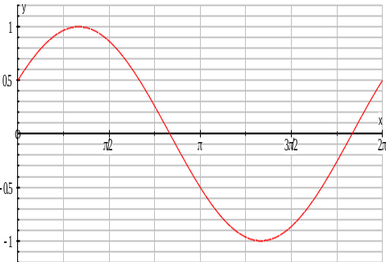
- (a) Sine wave (anywhere) with at least 2

turning points. M1

Starting on positive y-axis, going up to a

max., then min. below x-axis, no further

turning points in range, finishing above

x-axis at x = 2π or 360°. There must be

some indication of scale on the y-axis…

(e.g. 1, −1 or 0.5) A1 (2)

Ignore parts of graph outside 0 to 2π.

n.b. Give credit if necessary for what is seen on an initial sketch (before any

transformation has been performed).

(b) 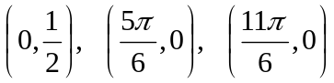 (Ignore any extra solutions) (Not 150°, 330°) B1, B1, B1 (3)

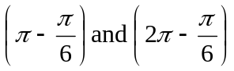 are insufficient, but if both are seen allow B1 B0.

(c) awrt 0.71 radians (0.70758…), or awrt 40.5° (40.5416…) (α) B1

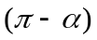 (2.43…) or 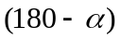 if α is in degrees. 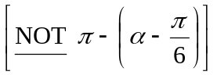 M1

Subtract 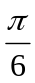 from (or from )… or subtract 30 if α is in degrees M1

0.18 (or 0.06π), 1.91 (or 0.61π) Allow awrt A1, A1 (5)

(The 1st A mark is dependent on just the 2nd M mark)

10 (b) The zeros are not required, i.e. allow 0.5, etc. (and also allow coordinates

the wrong way round).

These marks are also awarded if the exact intercept values are seen in part (a),

but if values in (b) and (a) are contradictory, (b) takes precedence.
- B1: If the required value of is not seen, this mark can be given by

implication if a final answer rounding to 0.18 or 0.19 (or a final answer

rounding to 1.91 or 1.90) is achieved. (Also see premature approx. note*).

Special case: 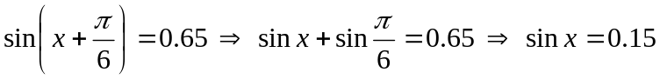

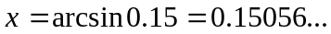 and 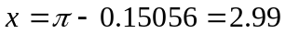 (B0 M1 M0 A0 A0)

(This special case mark is also available for degrees… 180 − 8.62…)

Extra solutions outside 0 to : Ignore.

Extra solutions between 0 and: Loses the final A mark.

*Premature approximation in part (c):

e.g. α = 41°, 180 − 41 = 139, 41 − 30 = 11 and 139 − 30 = 109

Changing to radians: 0.19 and 1.90

This would score B1 (required value of not seen, but there is a final

answer 0.19 (or 1.90)), M1 M1 A0 A0.

Question Scheme Marks
number

10. (a) 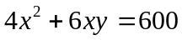 M1 A1

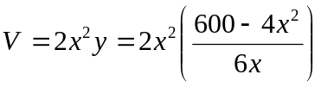 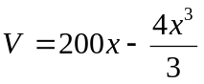 (*) M1 A1cso (4)

(b) 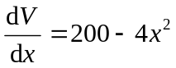 B1

Equate their 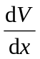 to 0 and solve for 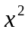 or x : 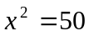 or x = √50 (7.07…) M1 A1

Evaluate V: 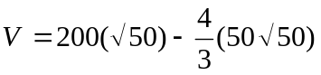 = 943 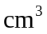 Allow awrt M1 A1 (5)

(c) 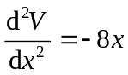 Negative, ∴ Maximum M1, A1ft (2) 11

(a) 1st M: Attempting an expression in terms of x and y for the total surface area

(the expression should be dimensionally correct).

1st A: Correct expression (not necessarily simplified), equated to 600.

2nd M: Substituting their y into 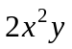 to form an expression in terms of x only.

(Or substituting y from into their area equation).

(b) 1st A: Ignore x = −√50, if seen.

The 2nd M mark (for substituting their x value into the given expression for V)

is dependent on the 1st M.

Final A: Allow also exact value 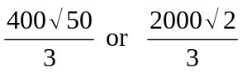 or equiv. single term.

(c) Allow marks if the work for (c) is seen in (b) (or vice-versa).

M: Find second derivative and consider its sign.

A: Second derivative following through correctly from their , and correct

reason/conclusion (it must be a maximum, not a minimum).

An actual value of x does not have to be used… this mark can still be

awarded if no x value has been found or if a wrong x value is used.

Alternative:

M: Find value of 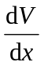 on each side of “x = √50” and consider sign.

A: Indicate sign change of positive to negative for , and conclude max.

Alternative:

M: Find value of V on each side of “x = √50” and compare with “943”.

A: Indicate that both values are less than 943, and conclude max.

